Supplementary Information for

A Quasi-3D Fano Resonance Cavity on Optical Fiber End-Facet for High Signal-to-Noise Ratio Dip-and-Read Surface Plasmon Sensing
Xiaqing Sun, Zeyu Lei, Hao Zhong, Chenjia He, Sihang Liu, Qingfeng Meng, Qingwei Liu, Shengfu Chen, Xiangyang Kong, Tian Yang*
Correspondence to: tianyang@sjtu.edu.cn

This file includes:

Supplementary Text
Figs. S1-S4
EQUIVALENT WAVELENGTH ORDER REVERSAL
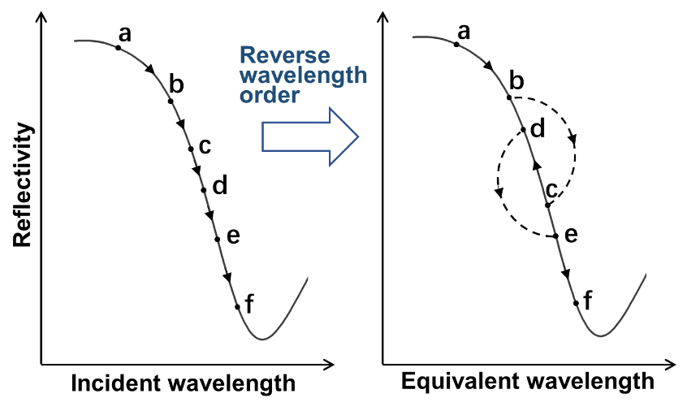
Fig. S1. Schematic illustration of equivalent wavelength order reversal. On the left, the points from a to f correspond to wavelengths of incident light, in the order of from short wavelength to long wavelength. The points are plotted on the reflectivity curve of the non-SPR etalon. On the right, the points are moved to their corresponding equivalent wavelengths, which give the SPR-coupled etalon’s reflectivity. The order of c and d is reversed.
SPP TUNNELING THROUGH NANOCAP-SLITS
To avoid a large-area direct contact between the SiO₂ etalon body and the quartz glass substrate, which would bind the nanostructure with the substrate firmly and disable the transferring, a gold nanocap was deposited above each nanoslit. The dimensions of the nanocap-slits are defined in Fig. S2a. The SMF-coupled reflectivity spectra of bare plasmonic cavities with different dimensions are shown in Fig. S2b. All cavities have the same geometric parameters as that of Fig. 2b, except for the gap distance, q, between the nanocap and nanoslit. The results show that when the gap is closed the fiber-guided lightwaves don’t tunnel through the continuous gold film to excite the water-interface SPP mode, and that as the gap opens the tunneling recovers.
EFFECTS OF ADHESION LAYERS ON OPTICAL RESONANCES
To assist peeling the quasi-3D nanostructures off the substrates, adhesion layers need to be added between the gold layers and the SiO₂ layer. However, the ohmic absorption of the common metal adhesion layers was found to worsen the Q factor of F-P resonance, in certain cases significantly. Therefore, it is important to choose the appropriate adhesion layers. In Fig. S3, the simulation results for bare etalons (without nanocaps or slits) and Fano resonance cavities, with titanium and chromium layers of difference thicknesses, are plotted. A 2 nm titanium layer was chosen for making the experimental devices.
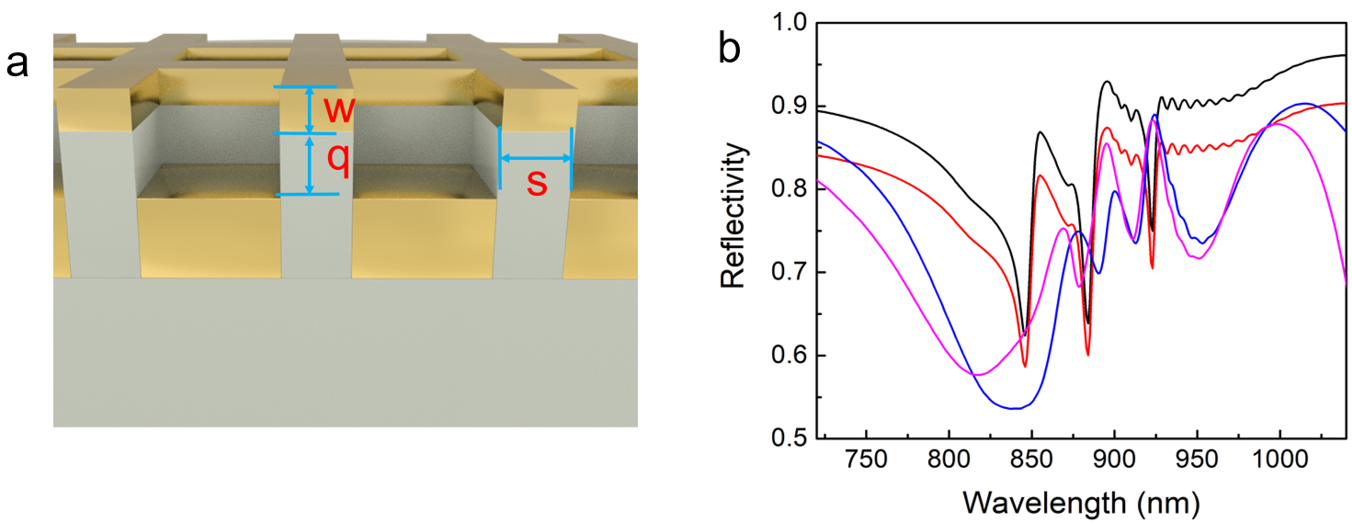
Fig. S2. Simulation of SPP tunneling through nanocap-slits. (a) Schematic diagram of the nanocap-slit array. w=5 nm is the thickness of gold nanocaps, s=50 nm is the width of nanocaps and nanoslits, and q is the gap distance between the nanocaps and the top gold film. (b) Normalized reflectivity spectra for different q values. q= -5 nm (violet), 0 nm (blue), 5 nm (red), 10 nm (black, same as Fig. 2b).
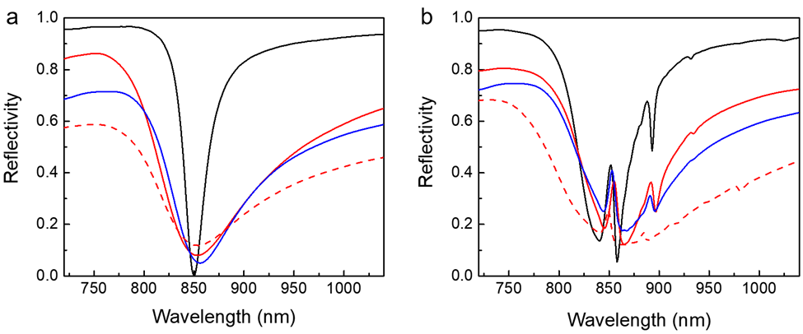
Fig. S3. Simulation with different adhesion layers. (a) Reflectivity spectra of bare F-P etalons, in which there are no nanocaps or slits in the top metal film. (b) Reflectivity spectra of Fano resonance cavities, p₁= 645 nm. The adhesion layers are none (black solid lines), 2 nm titanium (red solid lines), 5 nm titanium (red dotted lines) and 2nm chromium (blue solid lines), respectively.
EFFECTS OF UNEVENESS OF THE BOTTOM METALLIC LAYER
Although the bottom surface of the SiO₂ layer is flatter than the top metallic layer with nanoslits (using an orientation in which the fiber sensor is facing upwards), since the PECVD deposition process filled in the nanoslits and flattened the surface to a certain degree, the effect of unevenness in the bottom metallic layer should still be considered for device design purpose. In Fig. S4, we show simulation results with trapezoid- and arc-shaped structures in the bottom metallic layer, with different heights. It can be seen that the Fano resonance spectra are not considerably affected.
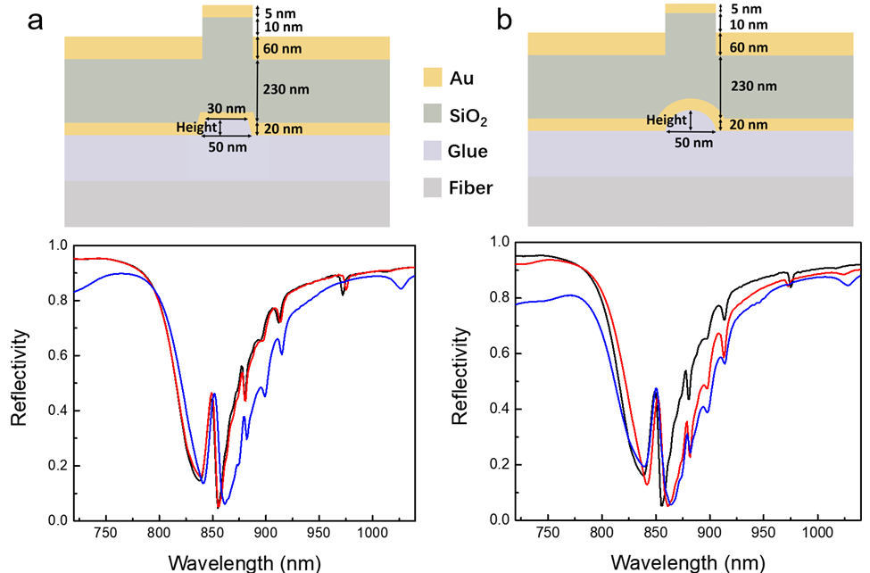
Fig. S4. Simulated reflectivity spectra of Fano resonance cavities with unevenness in the bottom metallic layer. The uneven structure’s in-plane position is aligned to the nanoslits, and its height is 0 nm (black), 20 nm (red) and 40 nm (blue); p₁= 645 nm. (a) Trapezoid-shaped structure. (b) Arc-shaped structure.
DISCUSSION ON BIOSENSING LOD (IN TERMS OF MOLECULAR CONCENTRATION)
The following discussion was written for reviewers and potential readers to assist their understanding and evaluation of label-free biosensing device reports. In the field of optical label-free biosensing device research (based on biomolecular interaction and refractive index monitoring), there have been an amount of publications trying to show an ultralow LOD of target molecule concentration in a “real” biological experiment. It has become popular to use such a molecular concentration LOD as the ultimate figure-of-merit to compare different devices [33]. Unfortunately, these high claims often didn’t agree with their LOD in terms of refractive index, many of them being several orders of magnitude more sensitive than what should be expected. In the following, we will discuss how to distinguish false molecular concentration LOD measurement results, is it possible to achieve an ultralow molecular concentration LOD by only working on the device itself, and is molecular concentration LOD necessary for evaluating a new physical device?
To ensure we obtain the correct molecular concentration LOD, we must be measuring signal from target molecules instead of fake signals. From biomolecule interaction physics, it is easy to tell typical false measurement results from the following aspects. We will assume a 1:1 analyte-receptor binding model for simplicity. (1) The binding rate should be approximately linearly proportional to [B], when [B]<k_{D}. Here [B] is the target molecule (analyte)’s concentration, and 1/k_{D} is the intrinsic affinity constant between the molecules. Often, a false claim of ultralow molecular concentration LOD came with a signal that increased linearly with log[B] at ultralow concentrations. (2) Some experiments only showed the balanced signals after the sensors had been immersed in the solutions for a long time. Since the balanced binding signal should reach its half maximum when [B]=k_{D}, the affinity constants could be estimated from these results. Unfortunately, often the extracted affinity value was several orders of magnitude higher than what it should be. (3) The binding rate can’t exceed R_{max}k_{a}[B]t, where R_{max} is maximum signal (corresponding to very large target concentration) and t is time. However, based on this rule, we can extract k_{a} values several orders of magnitude higher than what it should be from the ultrasensitive reports in the literature. For a list of precautions for correctly obtaining molecular concentration LOD, please see ref. [32].
From the above discussion, it is apparent that the high signals in some experiments didn’t come from the target molecules, which otherwise would implicate unreasonably high binding. However, is it possible to remove all the disturbances and interferences and extract the true signal, by just setting up a simple lab experiment, so that the device physicists can focus on device itself? The answer is negative. First, the ultimate molecular concentration LOD of a high performance sensor can only be achieved when it is embedded in an as high performance equipment. For example, to achieve pM LOD, the temperature variation usually must be on the mK level or less. In addition, a careful fluid mechanics design is critical to overcome the mass transfer barrier. Further, chemical and physical instabilities of the sensing surface will also show up as fake signals. Consequently, as mentioned in the main text, when the noise-equivalent LOD has been reduced to the 10⁻⁷ RIU level, with state-of-the-art commercial technologies, the real LOD for biosensing will be limited by factors other than SNR. In fact, we were limited by baseline fluctuation but not SNR when detecting BSA adsorption at ng mL⁻¹ concentration level (Fig. 6d).
According to the above reasoning, to demonstrate an ultrasensitive optical label-free biosensing device’s molecular concentration LOD is a multidisciplinary engineering task. However, in our opinion, it is not necessary to do so for evaluating the physical device itself, and it is not meaningful to develop ultrasensitive biological sensing applications before having a high performance instrument that fits the device, an appropriate fluid mechanics module that increases molecular binding rate to the maximum, and a highly stable sensing surface that efficiently and specifically captures the analytes. Very recently, it was reasserted by different groups that the physical performance of a label-free sensing device can be fully described by its SNR and its stability under environmental disturbances [31-33].
In conclusion, it is impractical to achieve an ultralow molecular concentration LOD by solely focusing on developing physical devices. On the other hand, we can fully describe the device’s physical performance by its SNR, physical stability and compatibility with fluid mechanics. With high regards for many pioneering works on ultrasensitive devices, we hope the above explanation could help us rethink of future research paradigms in this direction.

