Supplementary Information
Design and realization of 3D printed fiber-tip microcantilever beam probes applied to hydrogen sensing

Changrui Liao^{1,2,†}, Cong Xiong^{1,2,†}, Jinlai Zhao³, Mengqiang Zou^{1,2}, Yuanyuan Zhao^{1,2}, Bozhe Li^{1,2}, Peng Ji^{1,2}, Zhihao Cai^{1,2}, Zongsong Gan^{4,5}, Ying Wang^{1,2} and Yiping Wang^{1,2,*}

*Correspondence: Yiping Wang (ypwang@szu.edu.cn).
1Key Laboratory of Optoelectronic Devices and Systems of Ministry of Education/Guangdong Province, College of Physics and Optoelectronic Engineering, Shenzhen University, Shenzhen 518060, China.
2Shenzhen Key Laboratory of Photonic Devices and Sensing Systems for Internet of Things, Guangdong and Hong Kong Joint Research Centre for Optical Fibre Sensors, Shenzhen University, Shenzhen 518060, China.
3College of Materials Science and Engineering, Shenzhen Key Laboratory of Polymer Science and Technology, Guangdong Research Center for Interfacial Engineering of Functional Materials, Shenzhen 518060, PR China.
4Wuhan National Laboratory for Optoelectronics (WNLO), Huazhong University of Science and Technology (HUST), Wuhan 430074, China.
5Shenzhen Huazhong University of Science and Technology Research Institute, Shenzhen, Guangdong, 518057, PR China.

Robustness test:
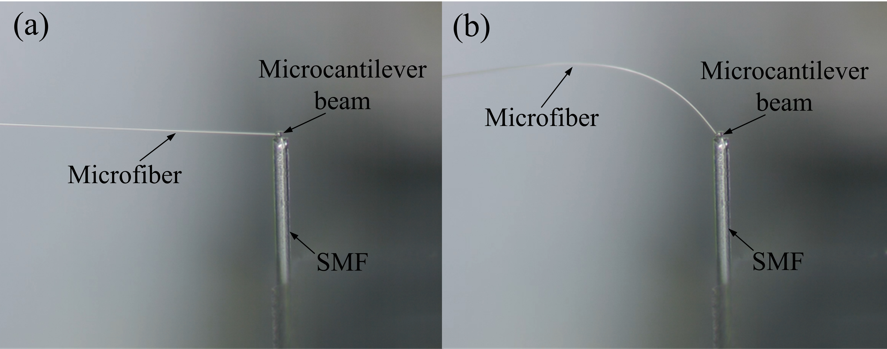
Fig. S1. Optical microscope images of the microcantilever beam probe before (a) and after (b) applying lateral stress on it by a tapered microfiber.
A microfiber with a diameter of 10 μm tapered from a standard single-mode fiber (SMF) is used to apply lateral force to the microcantilever base. The lateral force is adjusted by moving a precision translation stage to change the bending curvature of the microfiber. When the microfiber first touches the base, the microfiber remains straight with no lateral force on the base, as shown in Fig. S1(a). When the translation stage moves close to SMF, the lateral force acting on the base gradually increases, and the microfiber begins to bend under the reaction force. Fig. S1(b) shows the bending state of the microfiber when the translation stage moves to the right by 300 μm from the first touch point. Even when the microfiber is bent with a large curvature due to reaction force, the printed microcantilever beam probe is still firmly adhered to the fiber end face, indicating high robustness of the sensor. In particular, there is little lateral force applied to microcantilever base in hydrogen detection application. Thus, the robustness of this fiber hydrogen sensor is further verified. The experiment is recorded in Video. S1.
Repeatability test:
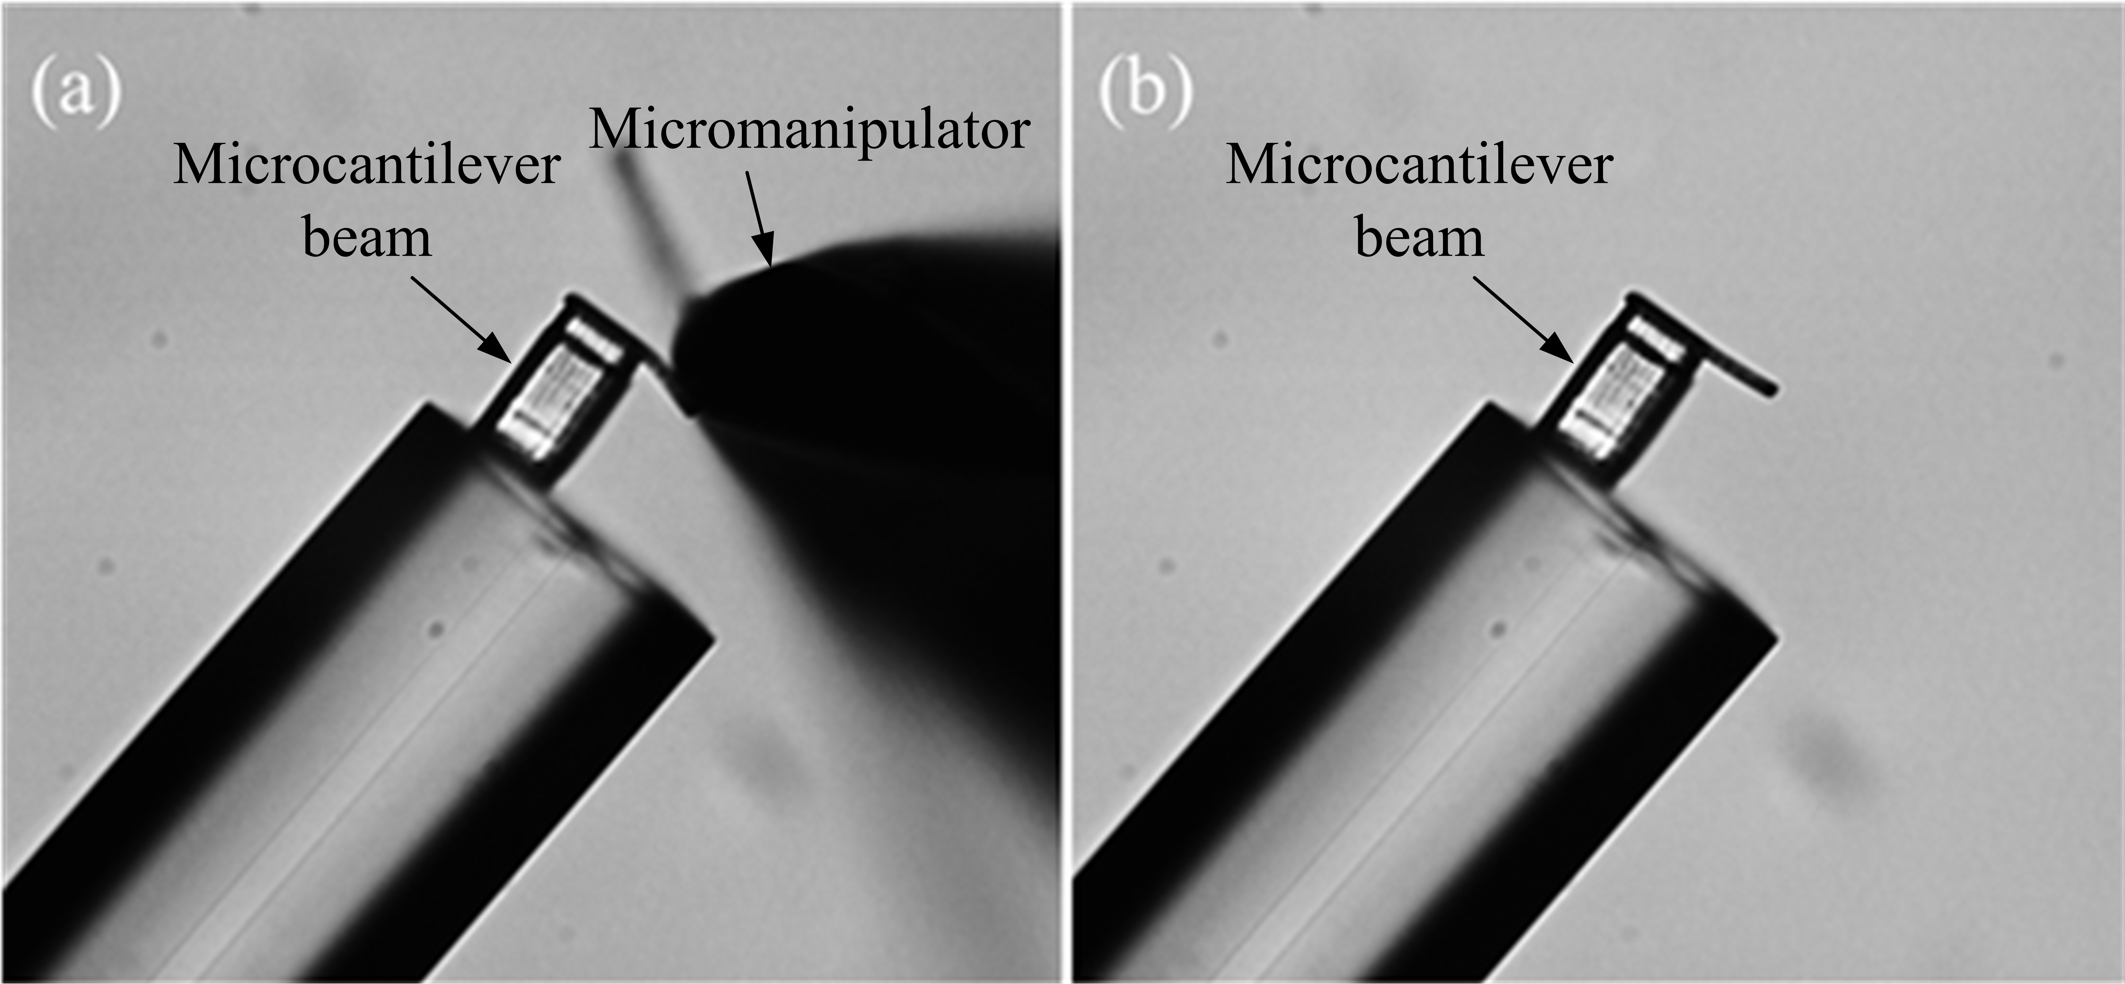
Fig. S2. Optical microscope images of the microcantilever beam being pressed by a micromanipulator tip (a) and released (b).
The hydrogen absorption induced expansion of Pd film is completely reversible1, so the repeatability of the sensor is mainly determined by the recovery of microcantilever beam under force-induced deformation. The polymer used in this work is a kind of resin polymer with good linear elasticity, similar to the polymer reported in Ref. 2. A micromanipulator tip is used to press the microcantilever beam to study its recovery response. Bending deformation is observed when the microcantilever beam is pressed and it is able to restore immediately once being released, as shown in Fig. S2(a) and (b). This verifies the microcantilever beam has high resilience. The hydrogen absorption induced expansion rate of Pd film is < 10% in volume3, thus the deflection of microcantilever beam caused by hydrogen absorption is much smaller than that resulting from micromanipulator tip pressing, which is reversible deformation. Therefore, this fiber hydrogen sensor can be repeatedly used for many times.
Reproducibility test:
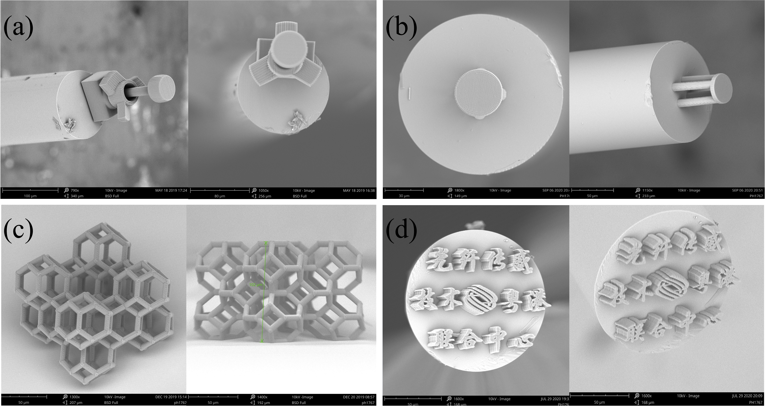
Fig. S3. SEM images of some micro/nano structures printed by TPP in our lab. (a) fiber-tip microturbines. (b) fiber-tip polymer FP interferometer. (c) metamaterial. (d) fiber-tip logo and name of our lab.
The scanning of TPP is accomplished by moving a 3D air-bearing translation stage system (Aerotech, X, Y-axis: ABL1500, Z-axis: ANT130V-5) with a spatial accuracy of ± 200 nm and a resolution of 2 nm. Fig. S3 shows the SEM images of some micro/nano structures printed by TPP using this translational stage in our lab, which demonstrates the high precision and good reproducibility of our femtosecond laser printing system.
Carbon dioxide and oxygen response test:
Fig. S4. Carbon dioxide response of the sensor. (a) Reflection spectra vs. carbon dioxide concentration. (b) Linear fit of the dip wavelength at different carbon dioxide concentration.
Fig. S5. Oxygen response of the sensor. (a) Reflection spectra vs. oxygen concentration. (b) Linear fit of the dip wavelength at different oxygen concentration.
The main components of gases exhaled by human body contains water, carbon dioxide, nitrogen and oxygen, hundreds of volatile organic compounds such as acetone, isoprene and acetone at the ppm or sub ppm levels, and about 400 volatile organic compounds at the ppb or ppt levels4. Compared with the high concentration of exhaled gas, the effect of exhaled trace gases on the sensor is negligible. Thus, in order to explore the real effect of the sensor in hydrogen respiration therapy, the responses of the sensor in the environment of carbon dioxide and oxygen have been studied respectively. Since the concentration of carbon dioxide in human exhaled gases is about 5%5, the response of the sensor in the mixture gases of carbon dioxide and nitrogen with a carbon dioxide concentration of 0% to 6% (v/v) has been studied, as shown in Fig. S4, which shows that the spectrum is hardly changed at different concentrations. A linear fit of dip wavelength at different carbon dioxide concentrations indicated a low sensitivity of 85 pm/%. Similarly, the response of the sensor in the mixture gases of oxygen and nitrogen with an oxygen concentration of 0 to 22% (v/v) has been studied because the oxygen concentration is about 16% in human exhaled gases and 21% in air5. The result is shown in Fig. S5. When the oxygen concentration increases from 0% to 22%, the dip wavelength is slightly changed as shown in Fig. S5(a). A linear fitting of dip wavelength at different oxygen concentrations demonstrates the sensitivity is 26 pm/% as shown in Fig. S5(b). The results prove that the main gases exhaled by human body have little cross effect on this fiber hydrogen sensor. The concentrations of other palladium-sensitive substances such as methane5 in human exhaled gases is so low that it is negligible.

Simulations of RHC with holes of different sizes:
Fig. S6. Finite-element simulations of RHC deflection with different size holes under the same unit area stress.
In order to study the influence of RHC hole size on sensor sensitivity, the deflections of RHC with holes of different sizes under the same unit area stress were simulated by finite element simulation, as shown in Fig. S6. As the hole size of RHC increases, the larger the deformation of microcantilever beam caused by the expansion of palladium film with the same thickness absorbing a certain concentration of hydrogen, and the higher the sensitivity. This can be attributed to the reduction of the effective width of the microcantilever beam, which makes the microcantilever beam more prone to deformation. However, the decrease in the effective width of the microcantilever beam may affect the parallelism of the microcantilever beam under the action of gravity. Hence, it is necessary to balance the sensitivity and robustness in the design of RHC.
Error analysis of three cycles hydrogen measurement:
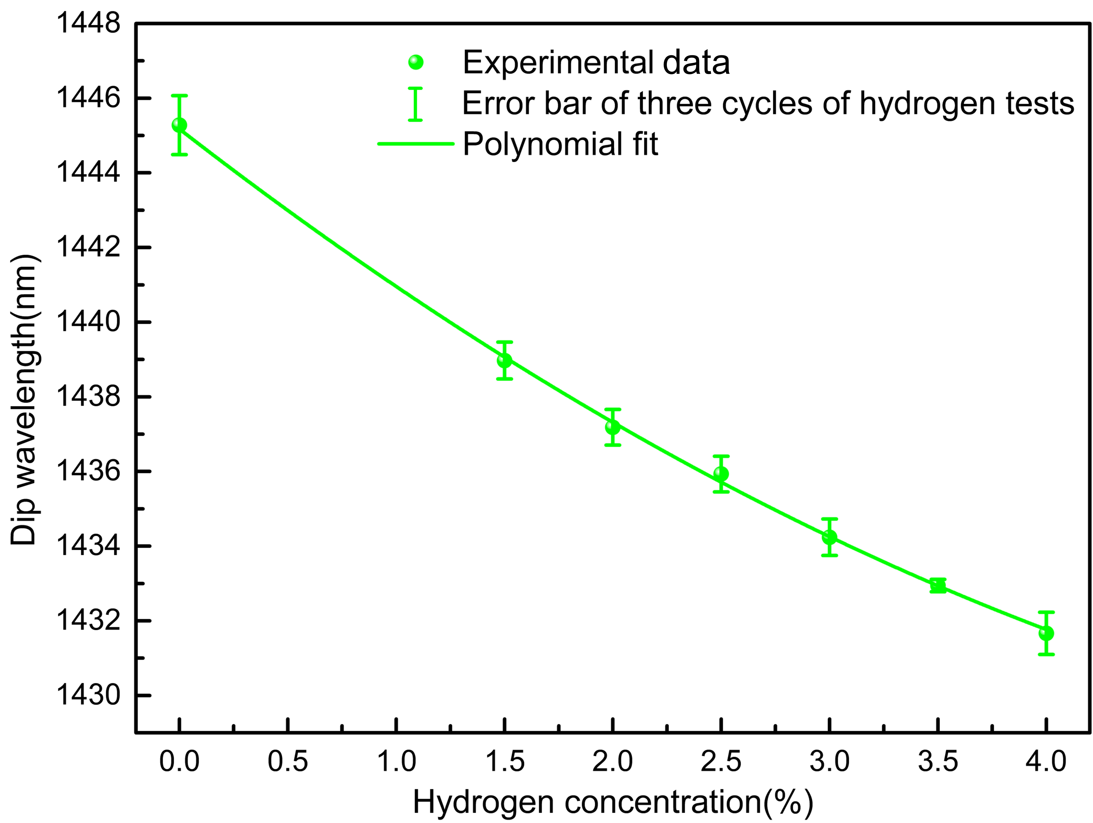
Fig. S7. The mean and standard error of traced interference dip wavelength at different hydrogen concentrations in three cycles of hydrogen test.
Fig. S7 shows the mean and the standard deviation of traced interference dip wavelength at different hydrogen concentration in the three cycles of hydrogen test. Except that the standard deviation of 0% concentration is 0.8 nm, the other measurement points are all less than 0.5 nm, which is nearly one order of magnitude lower than the sensitivity of the sensor, indicating that the hydrogen measurement of the sensor is relatively stable. As for the larger standard deviation at 0% hydrogen concentration, it may be caused by the fact that hydrogen molecules are not completely dissociated from the Pd film when hydrogen concentration decreases from 1.5% to 0% in the three cycles of hydrogen tests, which requires a relatively long time.
Temperature measurement:
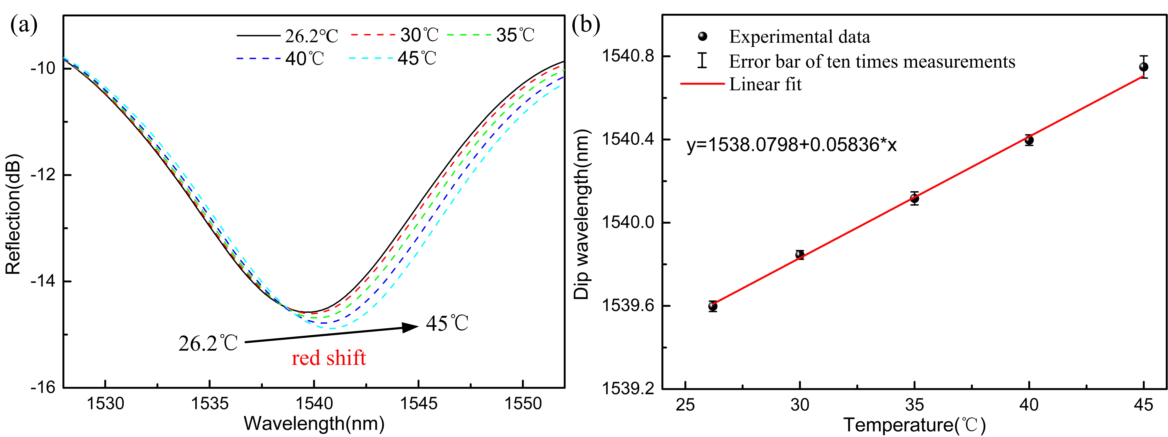
Fig. S8. Temperature response of the sensor. (a) Reflection spectra vs. temperature. (b) Linear fit of the dip wavelength at each temperature.
The air exhaled by the human body carries some heat, which may cause temperature instability in the pipes of the hydrogen respiratory system, causing crosstalk to the hydrogen sensor. Since the airflow temperature exhaled by humans is approximately 32 ℃6, the experiment of the sensor was studied at bio-temperature ranging from 26.2 ℃ to 45 ℃, as shown in Fig. S8. The dip wavelength shift of the FPI spectrum with temperature can be expressed by the following equation,
where and are the dip wavelength and an integer representing the order of the interference spectrum, respectively. and are the thermo-optic coefficient of the medium in the cavity and the thermo-expansion coefficient of the polymer, respectively. Since the medium in the air cavity formed by the fiber end face and the lower surface of the microcantilever beam is air, the refractive index of air barely changes as the temperature increases within the range of 26.2 ℃ to 45 ℃. Therefore, we believe the dominant reason is that the thermal expansion of the polymer bases of the microcantilever beam changes, leading to an increment of the cavity length. Fig. S8(b) illustrates the linear fit of the dip wavelength vs. temperature and the standard deviation from ten measurements at each temperature, achieving a sensitivity of ∼58 pm/℃. Thus, the temperature cross sensitivity of the hydrogen sensor is calculated to be less than 0.016%/℃, which means the 1℃ variation of temperature corresponds to 0.016% concentration of hydrogen.
Sensor resolution:
The resolution (R) of the sensor can be defined as the smallest variation of the hydrogen concentration that produces a measurable change in traced wavelength, which is determined by the measuring instrumentations, the noise sources and the methods of processing experimental data7. And the R is proportional to the sensor sensitivity (S). Therefore, the resolution of the sensor can be calculated by the following expression:
where is the standard deviation of multiple actual measurements at each hydrogen concentration, which includes the influence of temperature, humidity, measuring instrumentations, noise sources, experimental data processing methods and other influencing factors on the sensor. represents the confidence interval [68.3% (one sigma), 95.4% (two sigma), 99.7% (three sigma)]. In this experiment, we calculated the standard deviation of each measurement point with the data of three-cycle tests, and took the largest standard deviation as a representative to calculate the resolution of the sensor. The largest standard deviation is 0.79 nm at 0% measurement point, and the hydrogen sensitivity is 3.75 nm/%. Thus, the resolution of the sensor can be calculated as 0.144% (one sigma), 0.201% (two sigma) and 0.210% (three sigma) in different confidence interval.

Reference
- Lundstrom, I. et al. Physics with Catalytic Metal Gate Chemical Sensors. Crit. Rev. Solid State Mater. Sci. 15, 201-278 (1989).
- Zou, H. et al. Polymer/silica nanocomposites: preparation, characterization, properties, and applications. Chem. Rev. 39, 3893-3957 (2008).
- Hu, Z. Y. et al. Investigation of adsorption and absorption-induced stresses using microcantilever sensors. J. Appl. Phys. 90, 427-431 (2001).
- Wang, C. J. et al. Breath analysis using laser spectroscopic techniques: breath biomarkers, spectral fingerprints, and detection limits. Sensor 9, 8230-8262 (2009)
- Wojtas, J. et al. Ultrasensitive laser spectroscopy for breath analysis. Opto-Electron. Rev. 20, 26-29(2012).
- Bao, W. J. et al. Wearable breath monitoring based on a flexible fiber-optic humidity sensor. Sens. Actuators B Chem. 349, 130794 (2021).
- Chiavaioli, F. et al. Towards a uniform metrological assessment of grating-based optical fiber sensors: from refractometers to biosensors. Biosensors 7, 23 (2017).

