Supplementary Information for
Towards in-situ diagnostics of multi-photon 3D laser printing using optical coherence tomography

Roman Zvagelsky¹, Frederik Mayer¹, Dominik Beutel², Carsten Rockstuhl^{2,3}, Guillaume Gomard⁴, and Martin Wegener^{1,3,*}

¹ Institute of Applied Physics (APH), Karlsruhe Institute of Technology (KIT), 76131 Karlsruhe, Germany.
² Institute for Theoretical Solid State Physics (TFP), Karlsruhe Institute of Technology (KIT), 76131 Karlsruhe, Germany.
³ Institute of Nanotechnology (INT), Karlsruhe Institute of Technology (KIT), 76344 Eggenstein-Leopoldshafen, Germany.
⁴ Carl Zeiss AG, Zeiss Innovation Hub, Hermann-von-Helmholtz-Platz 6, 76344 Eggenstein-Leopoldshafen, Germany.

* Correspondence to Martin Wegener: martin.wegener@kit.edu

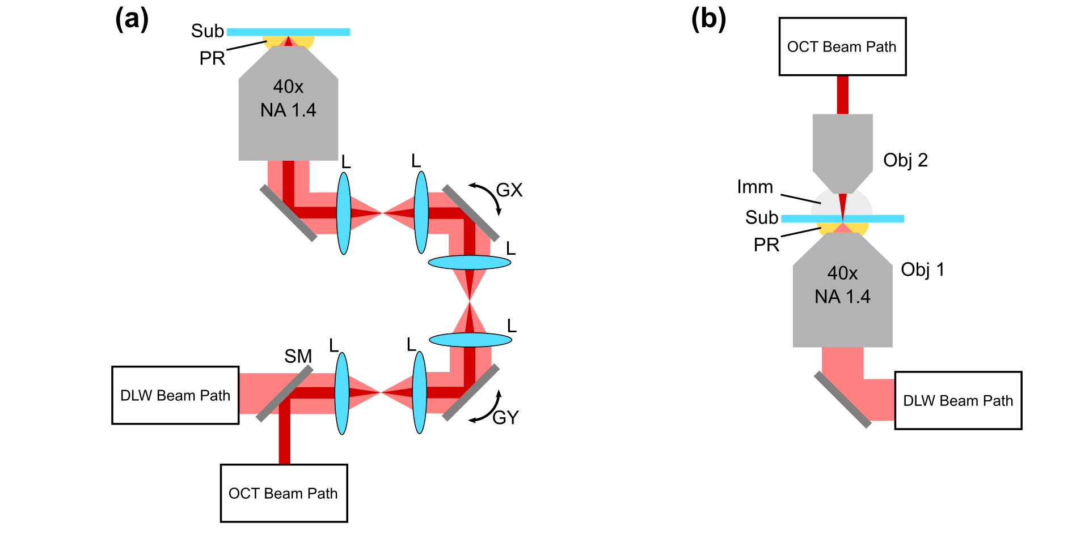

Fig. S1. Beam paths of a system combining two-photon printing and OCT imaging. a Common path, i.e., the printing laser and the OCT light beam impinge onto the specimen along the same optical axis and through the same microscope objective lens. (Sub: substrate; PR: photoresist; L: lens; GX, GY: galvo mirrors; SM: switchable mirror) b The two beams impinge from opposite directions and through two different microscope objective lenses. (Obj: objective; Imm: immersion oil; Sub: substrate; PR: photoresist)

To investigate the role of slicing distance for Bragg back-scattering, we perform transfer-matrix calculations of the reflectivity caused by a small periodic change of the refractive index in the z-direction. For the uni-hatching case, we model the refractive index profile as a single sinusoid (black curve, Figure S2a), so that the period of the function corresponds to a slicing distance with a refractive-index amplitude Δn_{amp} = 10⁻³ and its central value n₀ = n_{pol} = 1.545. To mimic an additional refractive index “inhomogeneity” (originating, for example, from cross-hatching), we use the sum of two sinusoids resulting in an amplitude deviation on a scale of Δn_{dev} ≈ 10⁻⁴ (red curve, Figure S2a). The wavelength and slicing distance distribution of the calculated reflectivity for the single sinusoid are shown in Figure S2b. The wavelength-averaged reflectivity for this case (Figure S2c) shows the peak at 280 nm slicing distance, which corresponds to the central Bragg wavelength of the SLD. The wavelength and slicing distribution of the calculated reflectivity for the case of additional refractive-index deviation is presented in Figure S2d. After averaging over wavelengths, the total reflectivity has an additional peak at 140 nm of slicing distance which originates from the model refractive-index inhomogeneity. The absolute values of the calculated reflectivity for the slicing distances of 140 nm and 280 nm are consistent with the experimental values in Figure 12. Thus, the model amplitude and deviation of the refractive index are rough estimations of the real refractive-index distribution resulting from sample slicing and cross-hatching, respectively. We would also like to note that the actual 3D refractive-index distribution of a printed structure has a much more complex behavior. To accurately calculate the Bragg scattering and explain the high contrast of all structures in Figure 12, one should also take into account the voxel size, proximity effect and dose accumulation. Such calculations are way beyond the scope of the present study.
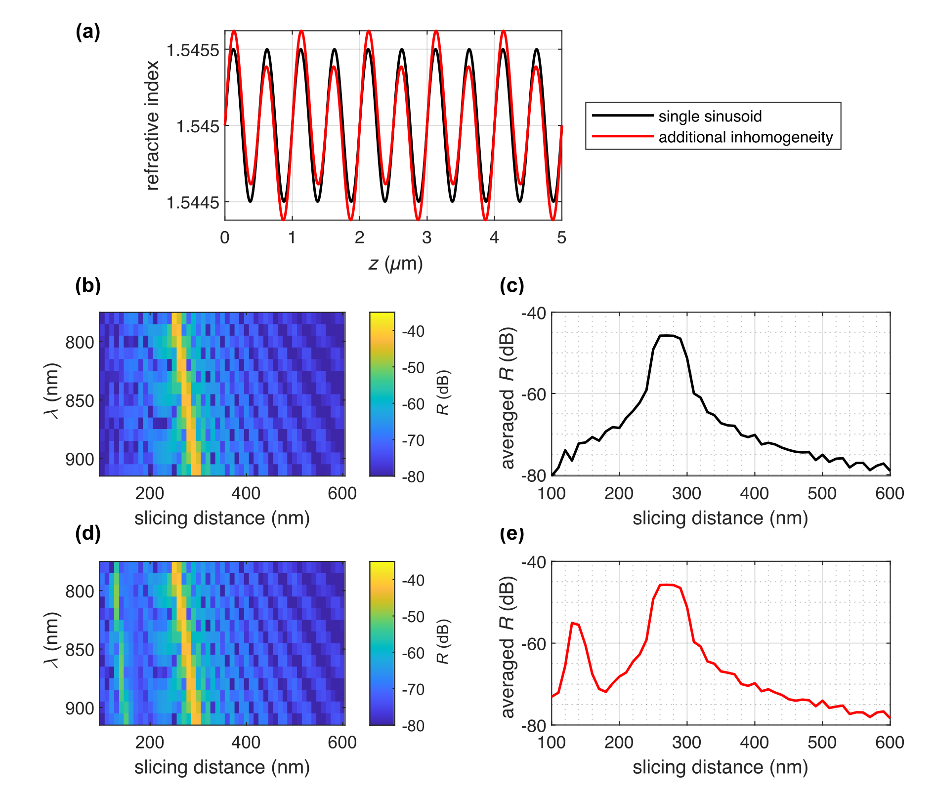

Fig. S2. Transfer matrix calculations of Bragg scattering signal. a Exemplary refractive index profiles represented by a sinusoidal function (black curve) with a period corresponding to a slicing distance of 500 nm and an amplitude of Δn_{amp} = 10⁻³ and a sum of sinusoidal functions (red curve) mimicking an additional “inhomogeneity” of the refractive index. b Reflectivity versus SLD wavelength λ and slicing distance calculated for a single sinusoid. c Wavelength-averaged reflectivity versus slicing for the single sinusoid. The peak at 280 nm slicing distance corresponds to the Bragg condition for the SLD central wavelength. d Reflectivity versus SLD wavelength λ and slicing distance calculated for the refractive-index profile with additional inhomogeneities. e Wavelength-averaged reflectivity versus slicing for the sum of sinusoids. An additional peak at 140 nm slicing distance appears due to Bragg back-scattering from the model inhomogeneity of the refractive index.

