Supplementary Information for
Fabrication of Opaque and Transparent 3D Structures Using a Single Material via Two-Photon Polymerisation Lithography
Parvathi Nair Suseela Nair^{1,*}, Chengfeng Pan², Hao Wang², Deepshikha Arora², Qing Yang Steve Wu¹, M. A. Rahman², Jinghua Teng¹ and Joel K. W. Yang^{1,2,*}
¹ Institute of Materials Research and Engineering (IMRE), Agency for Science, Technology and Research (A*STAR), #08-03 Innovis, 2 Fusionopolis Way, 138634, Singapore.
² Singapore University of Technology and Design, 8 Somapah Rd, Singapore 487372.
* joel_yang@sutd.edu.sg.
*parvathinsn@imre.a-star.edu.sg

1. Feature size with controlled opacity
We fabricated checkerboard structures with individual square side lengths varying from 5 µm to 25 µm to approximate the minimum feature size that can achieve uniform opacity. The heights of all structures were fixed at 30 µm, which is the minimum thickness that can provide a transmittance of less than 15%. First, the transparent squares were fabricated. Opaque squares were then exposed layer-by-layer, starting from the square in the lower left corner and ending at the square in the top right corner. After one layer was exposed at all opaque locations, the laser beam focus was moved back to the lower left square and the exposure process was repeated. The opaque regions for the checkerboard with 5 µm squares were mostly damaged and had a cloudy appearance rather than being non-transparent. These translucent regions appear to encroach on the transparent regions, thereby reducing their size. A checkerboard with 10 µm squares was fabricated with uniform opaque and transparent regions. For squares with sides of 15 µm and above, we observed non-uniform printing. The opacity was non-uniform, and the transparent regions were damaged. The bubbles formed in these structures appear to move laterally in the remaining liquid resin. The non-uniformity and damage to the transparent areas were attributed to the scattering of the laser beam by the bubbles during successive layer exposures.
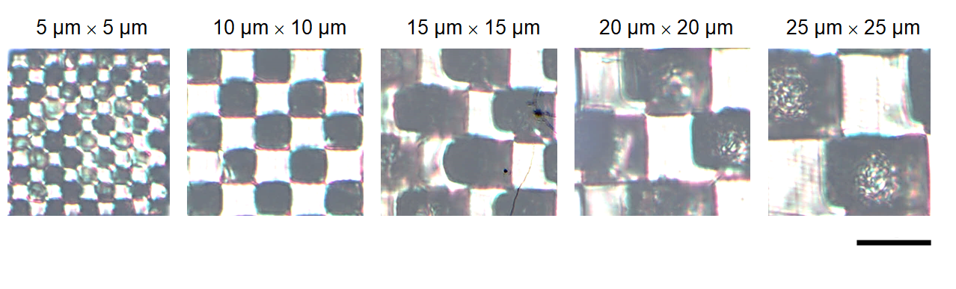
Figure S1:Microscopic image of checkerboard structures fabricated with TPL. Opaque regions are laser decomposed with high dose exposure. (Scalebar: 20 µm)

2.In-fill spacing and opacity
We fabricated opaque square structures with a side length of 50 µm to approximate the spacing required for the in-fill planes to achieve control over resin bubbling. The heights of the structures and planes were fixed at 30 µm, which is the minimum thickness that can provide the maximum opacity. The infill was fabricated by printing the contours. The spacing was varied from 5 to 25 µm to study the transmittance. An in-fill spacing of 10 µm yielded the lowest average transmittance of 18%, with a minimum transmittance of ~15% over the wavelength range of 400–800 nm. With an increase in spacing, we observed that the opacity became increasingly non-uniform.
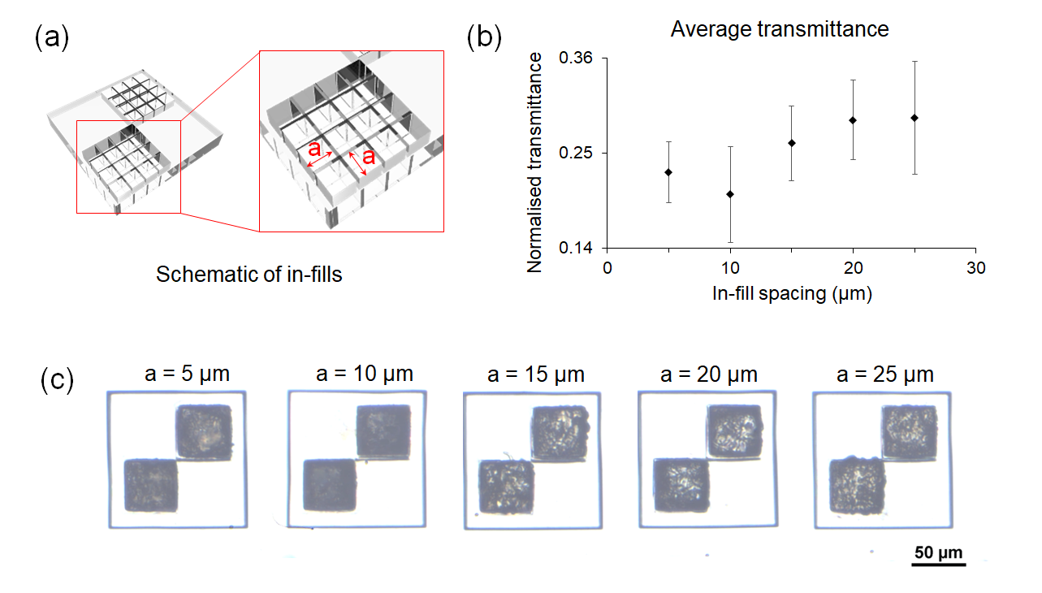
Figure S2: Opacity as a function of in-fill spacing. (a) Design of a square plate with transparent and opaque regions. (b) Average transmittance measured for different in-fill spacings. (c) Microscopic image of structures fabricated with different in-fill spacing.

