SUPPLEMENTARY MATERIAL
Large viewing angle holographic 3D display system
based on maximum diffraction modulation
Di Wang^{1,†}, Nan-Nan Li^{1,†}, Yi-Long Li¹, Yi-Wei Zheng¹,
Zhong-Quan Nie², Zhao-Song Li¹, Fan Chu^{1, *}, Qiong-Hua Wang^{1, *}
1School of Instrumentation and Optoelectronic Engineering, Beihang University, Beijing 100191, China.
2Key Lab of Advanced Transducers and Intelligent Control System, Ministry of Education, Taiyuan University of Technology, Taiyuan 030024, China.
†These authors contributed equally to this work.
*Correspondence: F Chu, E-mail: chufan@buaa.edu.cn;
QH Wang, E-mail: qionghua@buaa.edu.cn

5 pages, 3 figures S1-S3

S1: Analysis of the conventional hologram and large-size hologram
In order to analyze the viewing angle of holographic 3D display more clearly, we take novel-look-up-table (NLUT) algorithm¹⁻² as an example to compare the difference between the proposed large-size hologram and the conventional hologram. Fig. S1(a) shows the flowchart of the NLUT algorithm.
Figure S1. Analysis of the conventional hologram and large-size hologram. a Flowchart of the NLUT algorithm. b Principle of the large-size hologram. c Relationship between the viewing angle and viewing area of the 3D object.
Firstly, the intensity and depth image data are extracted from the 3D object. Then, only the fringe pattern of the center points on each depth image is pre-calculated by Eq. (S1.1) and stored in the memory, which is called the principal fringe pattern (PFP).
(S1.1)
where x and y denote the coordinates of the point on the hologram plane. PFP (x, y) represents the light field distribution of the PFP. k₀ and z represent the wave number and diffraction distance, respectively. Finally, the large-size hologram can be simply calculated by translation and addition operation of PFPs.
The principle of the large-size hologram generated by the NLUT algorithm is shown in Fig. S1(b). The coordinate origin is set at the center of the SLM, and the size of the recorded 3D object is W. The distance between the 3D object and the SLM is Z. The size of the SLM is H. In the reconstruction process, the coordinates of the leftmost image point A’ and the rightmost image point B’ in the x-axis direction are recorded as x₁ and x₂, respectively. Then x₂-x₁=W. Due to the size limitation of the SLM, the maximum diffraction angle of image point A’ is usually smaller than the maximum diffraction angle ϕ of the SLM. At this time, the viewing area corresponding to image point A’ is EF’. In order to increase the viewing angle, the maximum diffraction angle ϕ of the SLM is taken as the maximum diffraction angle of the image point. According to the Fresnel diffraction theory and the geometric relationship of the reconstructed image, it is concluded that the size of the hologram is enlarged. At this time, the viewing area corresponding to image point A’ is expanded to EF. Therefore, when ϕ is used as the maximum diffraction angle of the image point, the size of the hologram of the recorded 3D object is larger than that of the SLM for an object with a large-size or a long diffraction distance.
Based on the maximum diffraction analysis, the hologram of each point of the 3D object is calculated separately, and the holograms of all object points are superimposed to generate a large-size hologram. According to the above analysis, the relationship between the viewing angle and viewing area of the 3D object by using the large-size hologram and conventional hologram at different diffraction distances is given. As shown in Fig. S1(c), with the increase of reconstructed distance, the viewing angle and the viewing area of the conventional hologram decrease significantly. However, the viewing angle of the large-size hologram keeps unchanged, and the viewing area is obviously larger than that of the conventional method.
S2: Response time of the liquid crystal grating
The response time test method of the liquid crystal grating is shown in Fig. S2(a). The normalized transmittance of the liquid crystal grating placed in the crossed polarizers is measured. The rubbing direction of the liquid crystal molecules is set to 0º. The directions of the polarizer and analyzer are -45° and +45°, respectively. Then a pulse voltage (5 V) is applied to the liquid crystal grating. Fig. S2(b) shows the test response time of the liquid crystal grating. The switch-on and switch-off time of the liquid crystal grating are ~14.3 ms and ~17.9 ms, respectively.
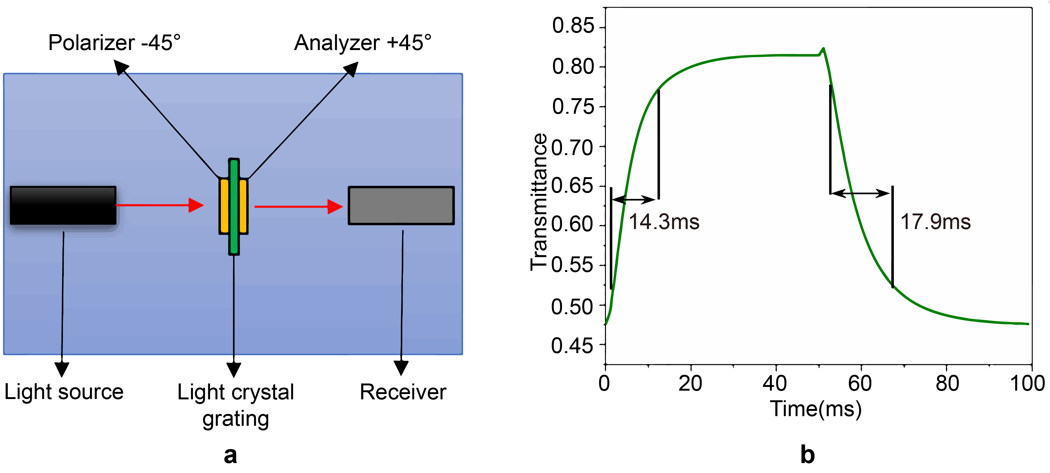
Figure S2. Response time of the liquid crystal grating. a Response time test method. b Response time of the liquid crystal grating.
S3: Measurement of diffraction efficiency of liquid crystal grating
The diffraction efficiency η_{N} of the liquid crystal grating is calculated as the ratio between the light intensity of diffraction order I_{N} and the total intensity I₀ when V = 0, which can be calculated by the following equation:
(S3.1)
Fig. S3(a) is the structure of diffraction efficiency measurement system, which consists of a laser, a polarizer, a liquid crystal grating, a signal controller and a photometer. The wavelength of the laser is 532 nm. The pitch of the liquid crystal grating is 20 µm. The photometer used in the experiments is TES-1330A. The measurement error range is controlled within 0.01 cd. Fig. S3(b) shows the diffraction efficiency of zero, first, second, third and fourth orders. The diffraction efficiency is similar for the ±1, ±2, ±3 and ±4 orders at 7.2 V.
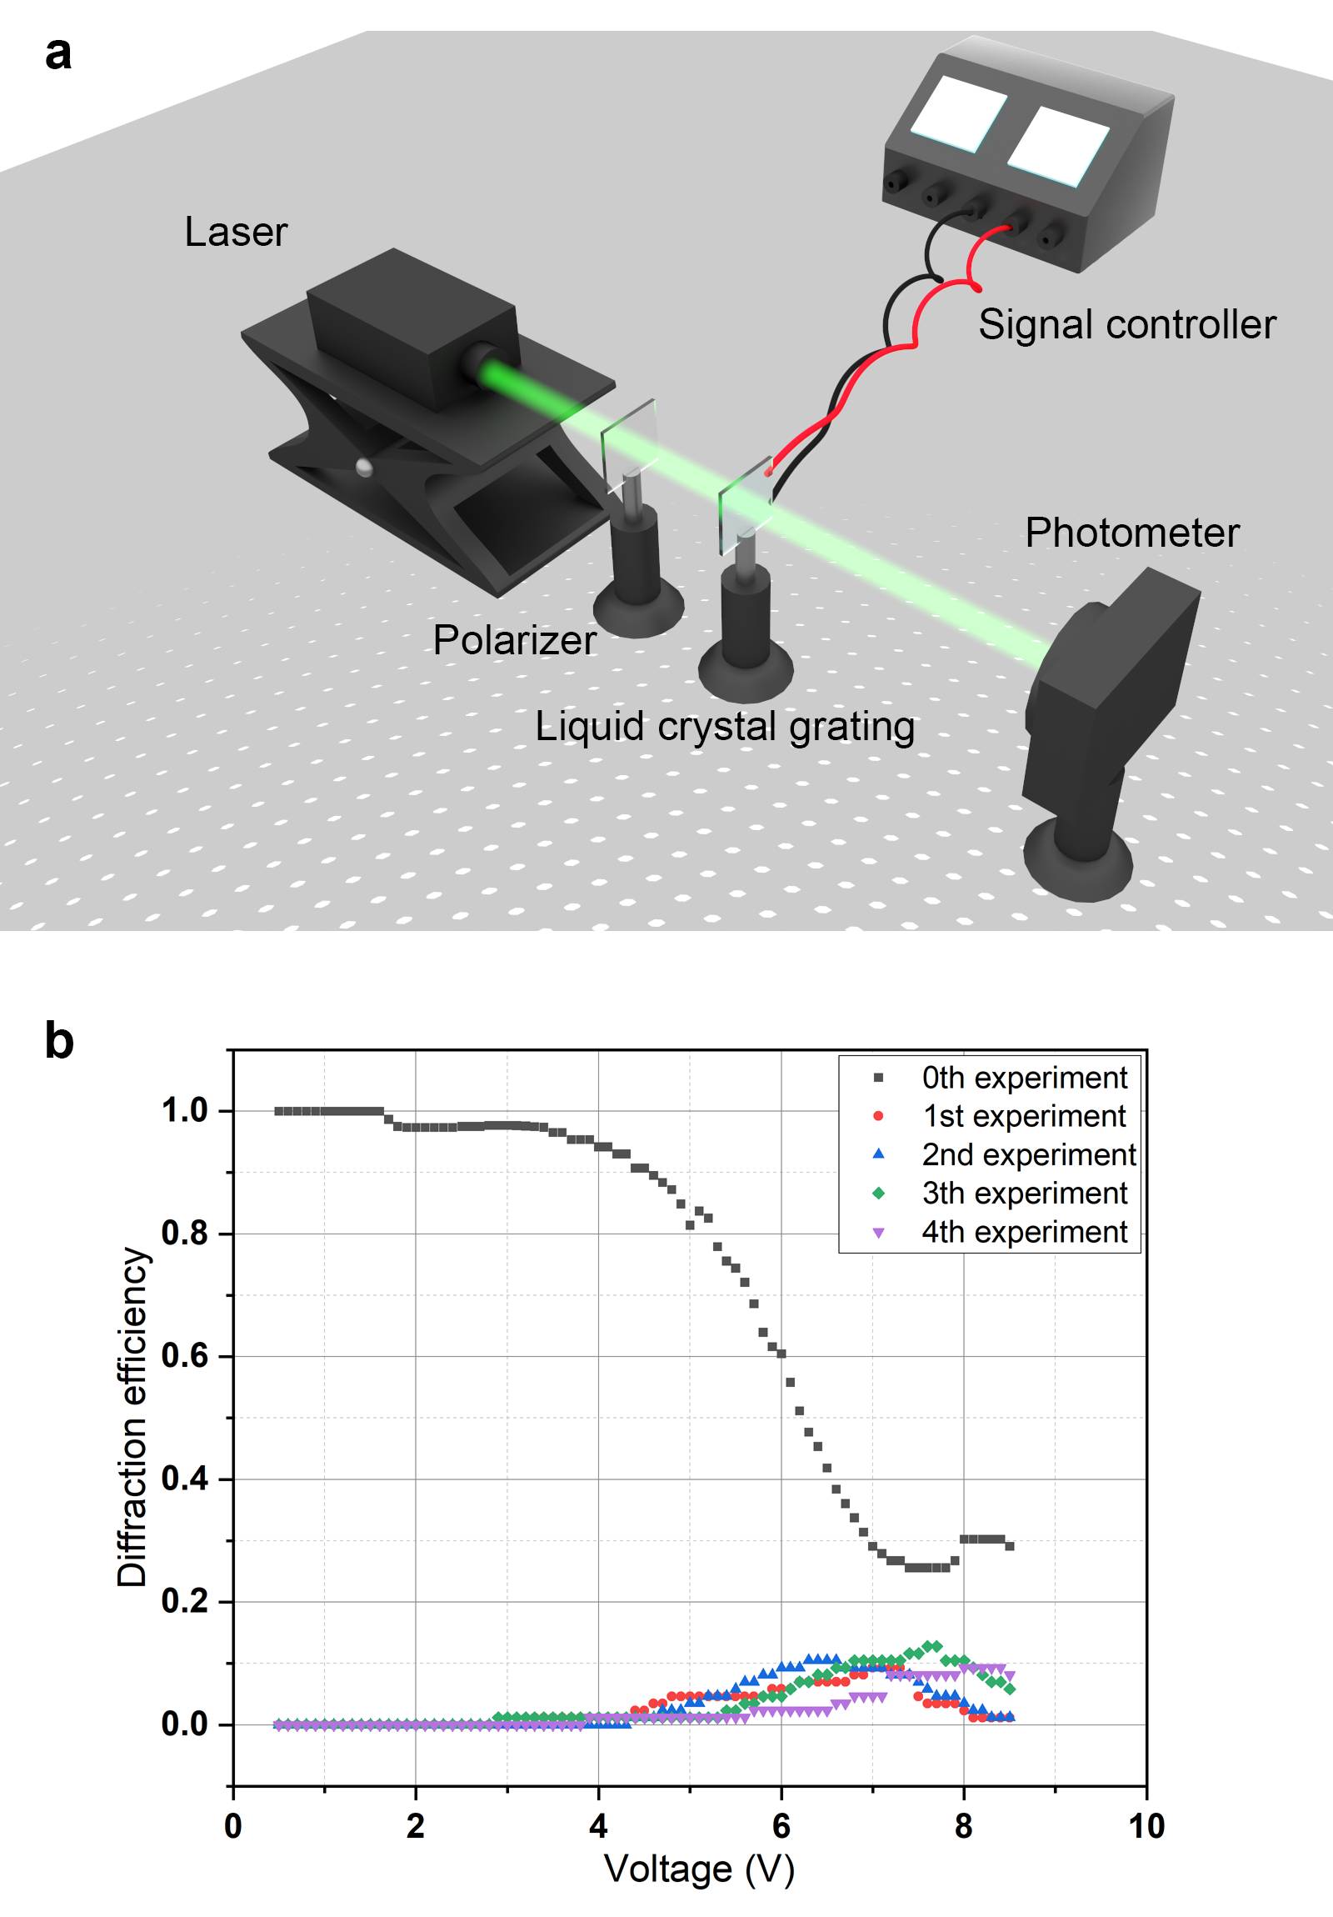
Figure S3. Measurement of diffraction efficiency of liquid crystal grating. a Structure of the diffraction efficiency measurement system. b Diffraction efficiency of the zero, first, second, third and fourth orders.
References
- Li, Y. L., Wang, D., Li, N. N., & Wang, Q. H. Fast hologram generation method based on optimal segmentation of sub-computer-generated hologram. Opt. Express 28(21), 32185-32198 (2020).
- Li, Y. L., Li, N. N., Wang, D., Chu, F., Lee, S. D., Zheng, Y. W., & Wang, Q. H. Tunable liquid crystal grating based holographic 3D display system with wide viewing angle and large size. Light Sci. Appl. 11, 188 (2022).

